PS Query & BI Publisher

Requirements:--

* Create and save PS Query to fetch active Employee’s Id, Name, DOB, Age, Department, and Location
* Generate XML files from PS Query
* Craete and save RTF template using table wizard.
* Generate PDF Report having list of active employee with details sort by Location.

Website:-- <http://www.psoftsearch.com/xml-bi-publisher-tutorial/>

Step1

Go to main menu🡪 Reporting Tools🡪Query🡪 Query Manager

Add new value🡪 A new page will open

Select a **record** according to your requirement.

Select the fields for which you want to generate the query.

Save it.

A new popup window will open 🡪 insert the query name🡪and all the details.

Step 2

Go to field🡪 and check for the fields🡪if u want to add criteria or edit do it.

Step 3

Go to view sql. And check the query.

Step 4

Run the sql and check output.

Step 5

Download xml.

**Now Register The Data Source**

Step 6

 Reporting Tools > BI Publisher > Data Source and clink on Add New Value.

Data source🡪 PS Query

Data Source ID🡪 EMPLOYEE_DT

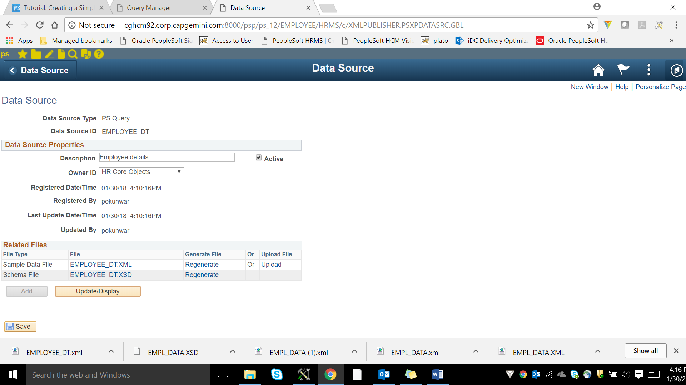

**Now Open Word🡪 BI Publisher**

Click on BI Publisher🡪 Sample XML 🡪 Load the downloaded xml File🡪 Data loaded successfully.

Click on Table Wizard🡪select all the related things🡪 click on finish.

Click on pdf 🡪 a pdf will be generated and save it.

**DEFINE REPORT DEFINITION**

Reporting Tools > BI Publisher > Report Definition and clink on Add New Value.

Provide a name for the report – EMPLOYEE_RP.  
Select PS Query from the Data Source Type list.  
Select Data Source Id as **EMPLOYEE_DT** that we created earlier.

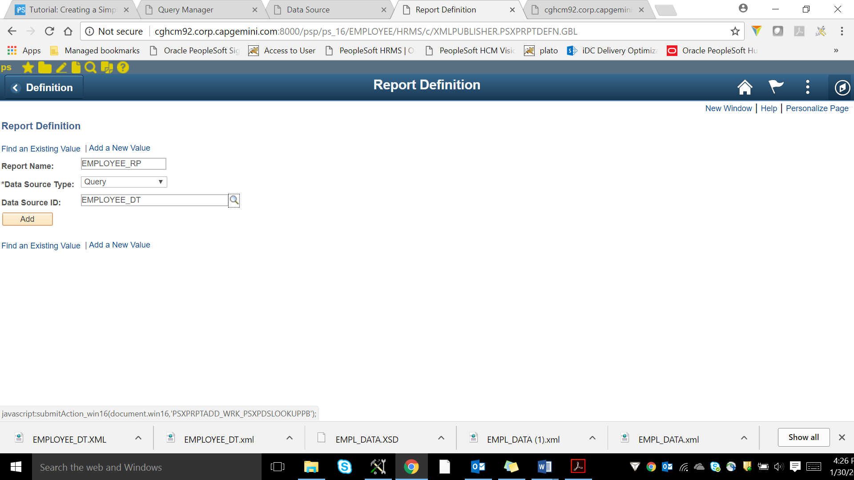

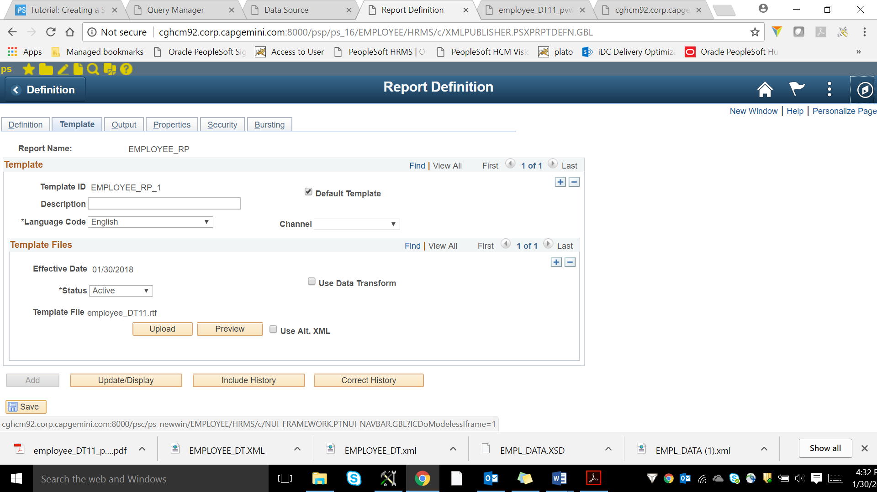

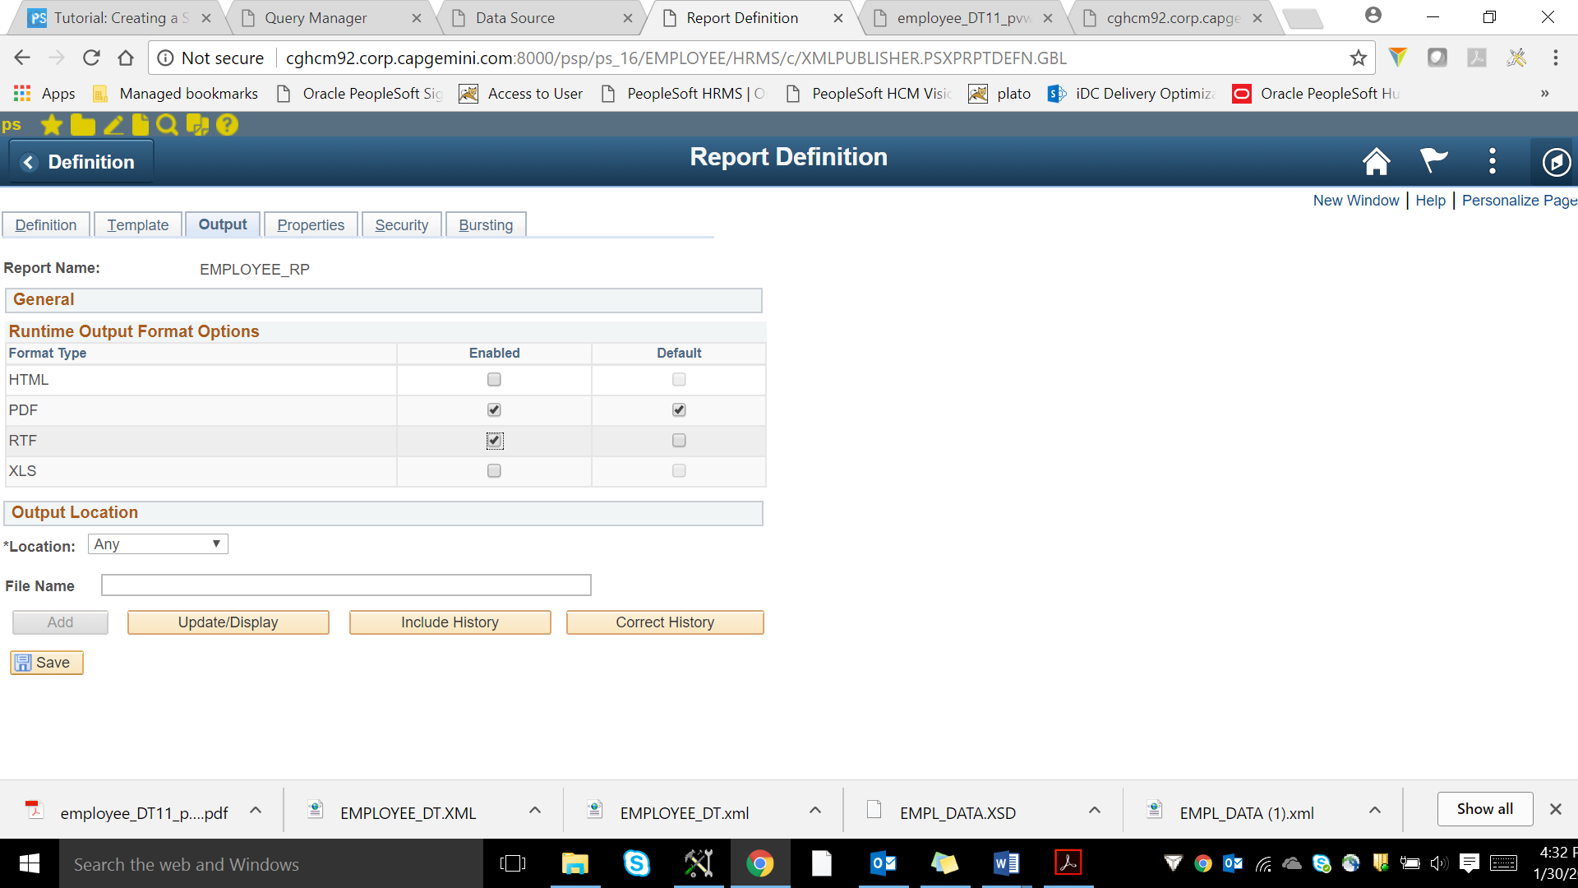

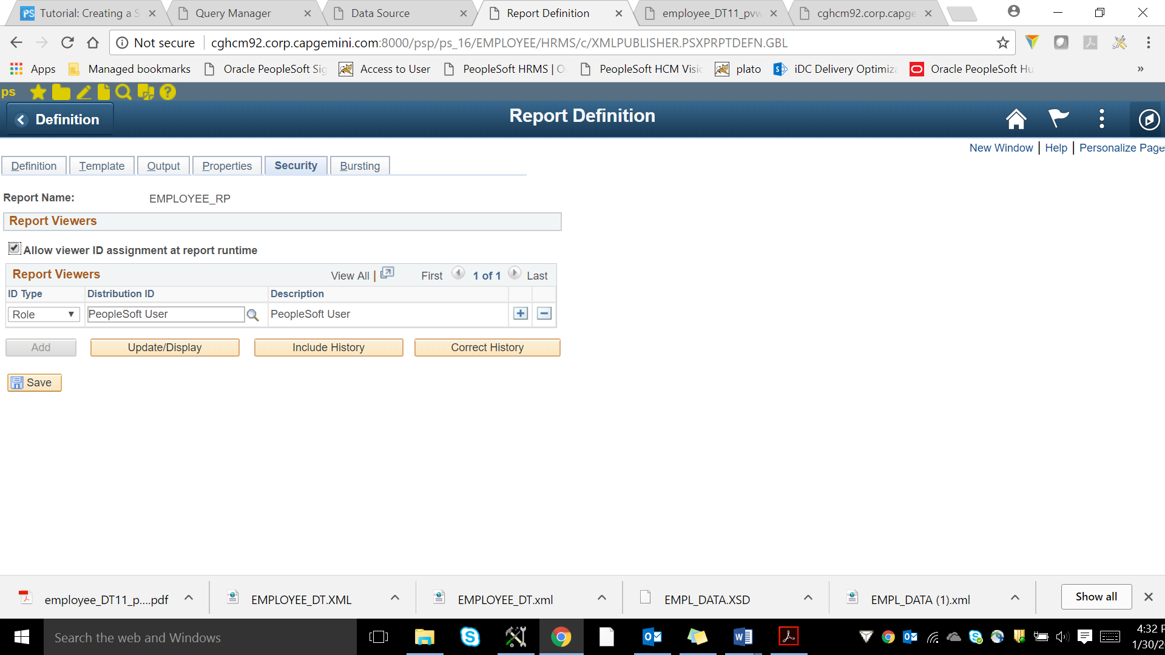

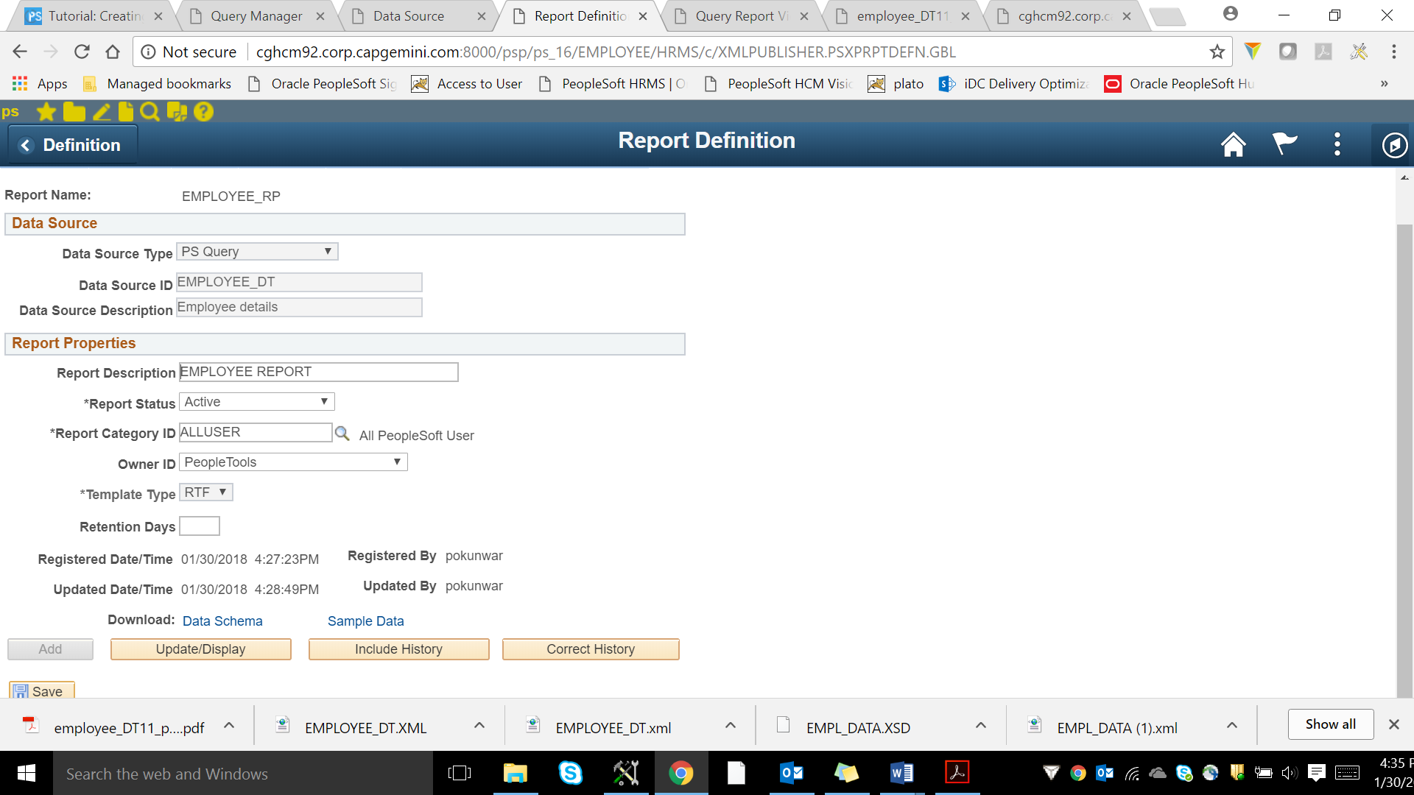

Reporting Tools🡪BI Publisher🡪 Query Report Viewer

Write report name 🡪 EMPLOYEE_RP

You will be able to see both the options and select according to it.

